Broadridge Trade Transmission Process Flow

1- Trades From Gresham and FTP

- Step 1: Trade data from Gresham or FTP feeds into the tradeloadstaging.dbo.messageinbound table.

- Step 2: The trigger [Name:ProcessTrade] kicks off in the tradeloadstaging.dbo.messageinbound table and loads the trade data into the db.trade table in the Trade Transformation/IREP Staging DB Server 10.1.10.15.

- Step 3: The trigger [name SendTrade] on Server tradeloadstaging kicks off in the db.trade table to transform trades into FIX message, puts them in the MSMQ and sends them to GEMS FIX Server 10.1.10.6.

Function Fn_send_single_msmq_mesage to call Assemblies MSMQ.dll.

get_TradeOutboundMQConfig

- Step 4: During the transformation process, the system generates status logs for all FIX trade messages and save them in the messageinbound_audit table. The logs show if the trade successfully transformed into an FIX message or failed.

Note: messageinbound_audit has the trades from Gresham/FTP and portal, and it does not works with the table tradeloadstaging.dbo.gems_acknack.

- Step 5: Once the trades are in the GEMS FIX Server 10.1.10.6, Raisul’s FIX Consumer process picks the messages and sends them to Broadridge GEMS and APPIA. This process runs in every 1 minute.

2- Trades From Client Portal

- Step 1: Trade data from the Client Portal feeds into the tradeloadstaging.dbo.trade_gui table.

- Step 2: The trigger kicks off in the tradeloadstaging.dbo.trade_gui table and loads the trade data into the db.trade table in the Trade Transformation/IREP Staging DB Server 10.1.10.15.

- Step 3: Same steps 3 through 5 in section 1

Add a Trade from Client Portal, and display

Step1: add a trade

Step2: search the trade just added.

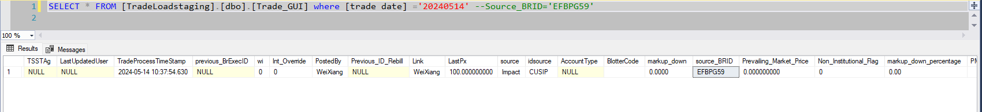





3- GEMS ACK/NACK Process

- Step 1: Once GEMS receives trade message from GEMS FIX Server 10.1.10.6, it returns ACK or NACK message as a confirmation. The ACK message indicates that the trade is booked successfully and the NACK message indicates that an error occurred when booking the trade.

- Step 2: Raisul’s FIX session puts the ACK/NACK message in the MSMQ and the SQL Agent Job load_gems acknackmessage usingSSISpackage in server 10.1.10.15 loads the data into the tradeloadstaging.dbo.gems_acknack table.

Note:

1. To cross check with the trades, link gems ack nack column Exec ID with table column Source_BRID to join check the process status column.
2. Column OrderStatus categorlize the status of trade.
3. New
4. Rejected

4- Data Load into DW Database and Display on Client Portal

The SQL Job TradeFeed_Load in DW Database (server 10.1.10.13) runs every 1 minute to load trade and ACK/NACK data from the Staging Database (server 10.1.10.15) into the DW Database as described below.

Update table dw.irep.TRANFILP_DW

table dw.Derived.outrightdescription

Delete Trade from dw.TradeFeed.gemsacknack

Update trade from dw.TradeFeed.Fixedincome

Trade from dbo.trade_gui

Stored procedure [TradeFeed].[LoadTradedata]

from irep.TradeLoadstaging.dbo.dweqtrade

For the trades, the job takes centralized data from the dbo.trade and dbo.trade_gui tables and loads it into the DW.tradefeed.fixedincome table.

For the ACK/NACK, the job takes the data from the tradeloadstaging.dbo.gemsacknack table and loads it into the DW.tradefeed.gemsacknack

The Trade Processing Queue function in the portal takes the data from the DW.tradefeed.fixedincome and DW.tradefeed.gemsacknack tables and displays it on the portal GUI.

All trades in the portal Trade Processing Queue can be cancel or rebill.

Rebill stands for cancel and new trade, for cancel trade it will same Exec ID for new trade new exec ID,

Currently, from business perspective, Trader can make same account of identical trades.

Appendix

